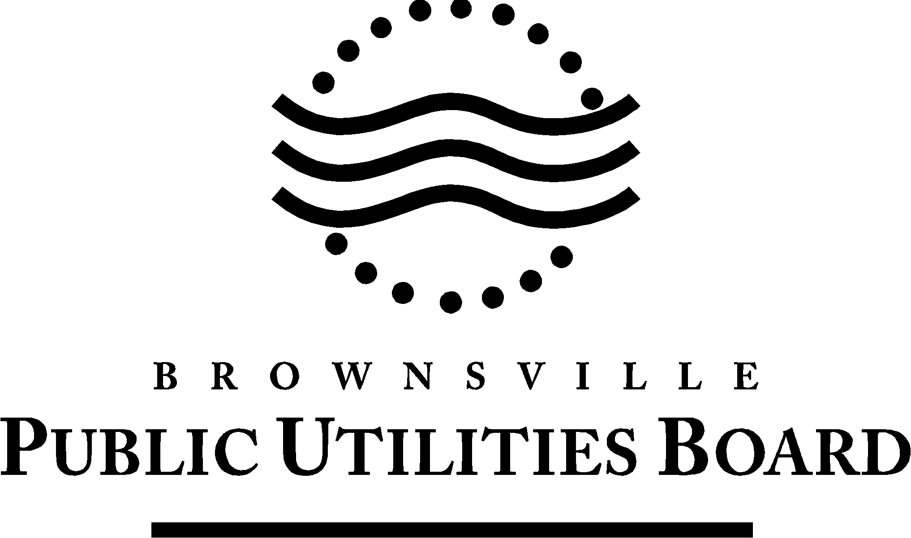
Date: October 22, 2024

To: All Vendors
Subject: Addendum #1

REFERENCE: B001-25 Supply of LED Fixtures

This Addendum forms part of the contract and clarifies, corrects or modifies original bid document.

Question 1: Would the Brownsville Public Utilities Board accept partial bids for materials, as in, could we bid for all the flood luminaires and decline to bid for the cobra luminaires?

Answer 1: Yes, BPUB will accept partial bids.

Question 2: We would likely be submitting a request for material approval, what is the cutoff for pre-approval submission?

Answer 2: Any new manufacturer or brand name must be pre-approved to be part of Brownsville PUB approved manufacture’s list. The last day to receive pre-approval submission is October 25, 2024 at 5:00 PM, and the part number and cut sheets for all material that is being requested for approval must be included.

The signature of the company agent, for the acknowledgement of this addendum, shall be required. Complete information below and return via e-mail to: dsolitaire@brownsville-pub.com.

I hereby acknowledge receipt of this addendum.

Company:

Agent Name:

Agent Signature:

Address:

City: State: Zip:

Phone Number: E-mail address:

If you have any further questions about the Bid, call 956-983-6375.

BY: Hugo E. López
Purchasing

