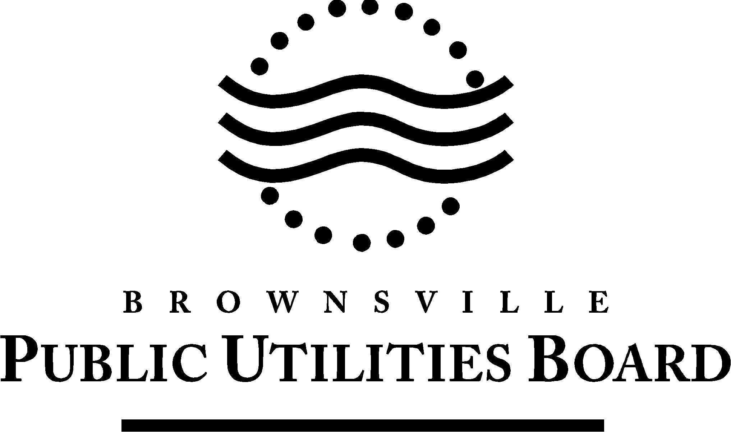

Date: June 26, 2024

# To: All Vendors

Subject: Addendum #1

REFERENCE: **B052-24 Annual Supply of Water & Wastewater Chemicals for BPUB & SRWA**

This Addendum forms part of the contract and clarifies, corrects or modifies original bid document.

**Question 1:** How much material (PAC) does your system hold?  Does BPUB you have a silo?

**Answer 1:** BPUB does not have a silo. BPUB has a carbon slurry tank that can hold 40,000 lbs.

**Question 2:** Can you provide additional details to the threshold test referenced on page 29 for PAC rejection?

**Answer 2:** The water plants use activated carbon for the removal of taste and odor. Therefore, the activated carbon needs to remove at least 70% of the odor. If BPUB staff notices the carbon is not removing the taste and odor from the water; they will run a threshold test in accordance with the Standard Methods for the Examination of Water and Wastewater.

**Question 3**: What is the anticipated start date of the contract?

**Answer 3:** The contract anticipated start date is September 1, 2024.

**Question 4:** Please confirm if a bid bond is required.

**Answer 4**: A bid bond is not required.

**Question 5**: Please confirm if the OSHA log is required?

**Answer 5**: The OSHA log is not required.

**Question 6:** Please confirm if the pre-bid disclosure is required – bid doc did not mention a pre-bid.

**Answer 6:** The pre-bid disclosure form is not required.

The signature of the company agent, for the acknowledgement of this addendum, shall be required. **Complete information below** **and return via e-mail to:** [**nespinoza@brownsville-pub.com**](mailto:nespinoza@brownsville-pub.com)

I hereby acknowledge receipt of this addendum.

**Company:**

**Agent Name:**

**Agent Signature:**

**Address:**

**City:**   **State:**  **Zip:**

**Phone Number:**  **E-mail address:**

If you have any further questions about the Bid, call 956-983-6353.

BY: Diane Solitaire

Purchasing